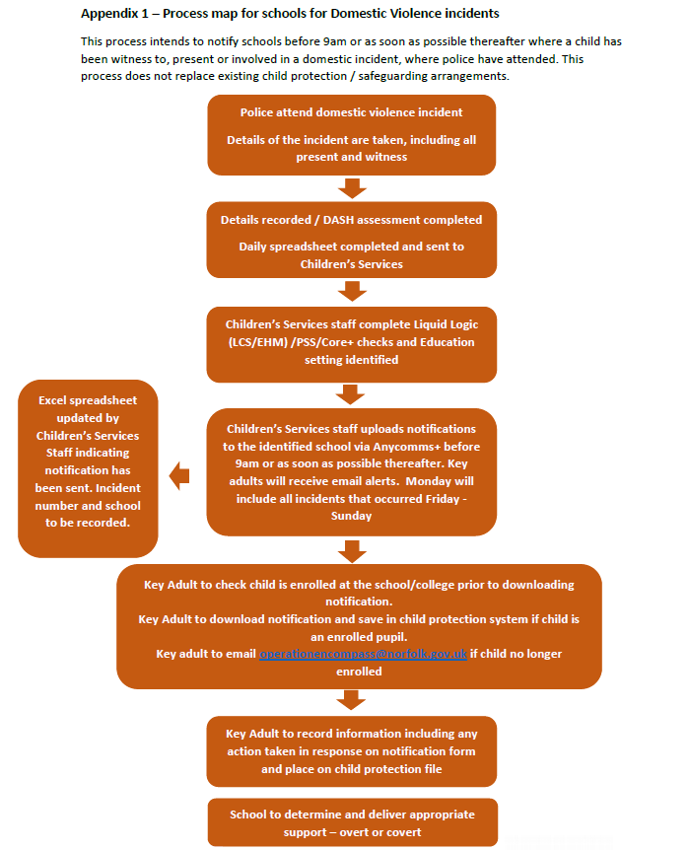
You can find further information from this website www.operationencompass.org

